Type of the article (Article, discussion, review, communication, …)
Title
Firstname Lastname ¹, Firstname Lastname ² and Firstname Lastname ^{2,}*
¹ Affiliation 1; e-mail@e-mail.com
² Affiliation 2; e-mail@e-mail.com
³ Affiliation 3; e-mail@e-mail.com
* Correspondence: e-mail@e-mail.com; Tel.: (optional; include country code; if there are multiple corresponding authors, add author initials) +xx-xxxx-xxx-xxxx (F.L.)
Manuscript received: , revised: , accepted: .
Abstract
A single paragraph of about 150-200 words maximum. For research articles, abstracts should give a pertinent overview of the work. We strongly encourage authors to use the following style of structured abstracts, but without headings: (1) Background: Place the question addressed in a broad context and highlight the purpose of the study; (2) Methods: Describe briefly the main methods or treatments applied; (3) Results: Summarize the article's main findings; and (4) Conclusions: Indicate the main conclusions or interpretations. The abstract should be an objective representation of the article, it must not contain results which are not presented and substantiated in the main text and should not exaggerate the main conclusions.
Keywords: keyword 1; keyword 2; keyword 3 (List three to ten pertinent keywords specific to the article; yet reasonably common within the subject discipline.)

1. Introduction
The introduction should briefly place the study in a broad context and highlight why it is important. It should define the purpose of the work and its significance. The current state of the research field should be reviewed carefully and key publications cited. Please highlight controversial and diverging hypotheses when necessary. Finally, briefly mention the main aim of the work and highlight the principal conclusions. As far as possible, please keep the introduction comprehensible to scientists outside your particular field of research. References should be numbered in order of appearance and indicated by a numeral or numerals in square brackets, e.g., [1] or [2,3], or [4–6]. See the end of the document for further details on references.

2. Materials and Methods
Materials and Methods should be described with sufficient details to allow others to replicate and build on published results. Please note that publication of your manuscript implicates that you must make all materials, data, computer code, and protocols associated with the publication available to readers. Please disclose at the submission stage any restrictions on the availability of materials or information. New methods and protocols should be described in detail while well-established methods can be briefly described and appropriately cited.
Research manuscripts reporting large datasets that are deposited in a publicly available database should specify where the data have been deposited and provide the relevant accession numbers. If the accession numbers have not yet been obtained at the time of submission, please state that they will be provided during review. They must be provided prior to publication.
Interventionary studies involving animals or humans, and other studies require ethical approval must list the authority that provided approval and the corresponding ethical approval code.

3. Results
This section may be divided by subheadings. It should provide a concise and precise description of the experimental results, their interpretation as well as the experimental conclusions that can be drawn.

3.1. Subsection

3.1.1. Subsubsection
Bulleted lists look like this:
- First bullet
- Second bullet
- Third bullet
Numbered lists can be added as follows:
- First item
- Second item
- Third item
The text continues here.

3.2. Figures, Tables and Schemes
All figures and tables should be cited in the main text as Figure 1, Table 1, etc.
(a)
(b)
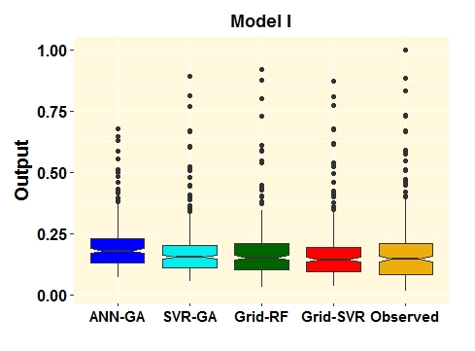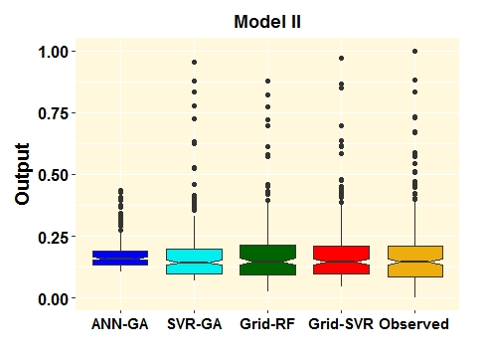
Figure 1. This is a figure, Schemes follow the same formatting. If there are multiple panels, they should be listed as: (a) Description of what is contained in the first panel; (b) Description of what is contained in the second panel. Figures should be placed in the main text near to the first time they are cited. A caption on a single line should be centered.
Table 1. This is a table. Tables should be placed in the main text near to the first time they are cited.
Methods | ME | RMSE | MAE | MPE | MAPE | R²
Training phase
ANN-GA | 0.02 | 0.09 | 0.06 | -0.47 | 0.58 | 0.63
SVR-GA | 0.003 | 0.09 | 0.06 | -0.32 | 0.48 | 0.68
Grid-RF | -0.0008 | 0.05 | 0.03 | -0.09 | 0.19 | 0.92
Grid-SVR | -0.005 | 0.10 | 0.06 | -0.21 | 0.45 | 0.58
Testing phase
ANN-GA | 0.02 | 0.08 | 0.06 | -0.62 | 0.71 | 0.69
SVR-GA | 0.003 | 0.06 | 0.05 | -0.30 | 0.48 | 0.78
Grid-RF | 0.0002 | 0.05 | 0.04 | -0.14 | 0.37 | 0.80
Grid-SVR | -0.002 | 0.04 | 0.03 | -0.13 | 0.28 | 0.91
¹ Tables may have a footer.

3.3. Formatting of Mathematical Components
This is an example of an equation:
 | $$\text{subject to} \{\begin{aligned}y_{k}-⟨w,x_{k}⟩-b≤ε+ξ_{k} \\ ⟨w,x_{k}⟩+b-y_{k}≤ε+ξ_{k} \\ ξ_{k},ξ_{k}^{*}≥0\end{aligned}$$ | (1)

the text following an equation need not be a new paragraph. Please punctuate equations as regular text.

4. Discussion
Authors should discuss the results and how they can be interpreted in perspective of previous studies and of the working hypotheses. The findings and their implications should be discussed in the broadest context possible. Future research directions may also be highlighted.

5. Conclusions
This section is not mandatory, but can be added to the manuscript if the discussion is unusually long or complex.
Acknowledgments: In this section you can acknowledge any support given which is not covered by the author contribution or funding sections. This may include administrative and technical support, or donations in kind (e.g., materials used for experiments).
Conflicts of Interest: Declare conflicts of interest or state “The authors declare no conflict of interest.” Authors must identify and declare any personal circumstances or interest that may be perceived as inappropriately influencing the representation or interpretation of reported research results. Any role of the funders in the design of the study; in the collection, analyses or interpretation of data; in the writing of the manuscript, or in the decision to publish the results must be declared in this section. If there is no role, please state “The funders had no role in the design of the study; in the collection, analyses, or interpretation of data; in the writing of the manuscript, or in the decision to publish the results”.

Appendix A
The appendix is an optional section that can contain details and data supplemental to the main text. For example, explanations of experimental details that would disrupt the flow of the main text, but nonetheless remain crucial to understanding and reproducing the research shown; figures of replicates for experiments of which representative data is shown in the main text can be added here if brief, or as Supplementary data. Mathematical proofs of results not central to the paper can be added as an appendix.

References
References must be numbered in order of appearance in the text (including citations in tables and legends) and listed individually at the end of the manuscript. We recommend preparing the references with a bibliography software package, “It is a must using Mendeley [https://www.mendeley.com/download-desktop-new/]” to avoid typing mistakes and duplicated references. Include the digital object identifier (DOI) for all references where available.

Citations and References in Supplementary files are permitted provided that they also appear in the reference list here.

In the text, reference numbers should be placed in square brackets [ ], and placed before the punctuation; for example [1], [1–3] or [1,3]. For embedded citations in the text with pagination, use both parentheses and brackets to indicate the reference number and page numbers; for example [5] (p. 10), or [6] (pp. 101–105).
Hint: Follow the style of the IEEE journal.

